A1341-**Peru-Chavin-Jaguar Votary-Crenelated crown, ca 250 BCE**

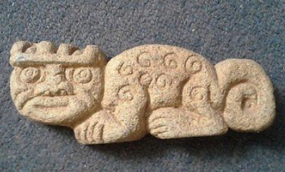

**Fig. 1. Chavin Jaguar Emblem with Crenelated Crown, ca 250 BCE**

**Formal Label: Peru-Chavin-Jaguar with Crenelated crown, ca 250 BCE**

**Accession Number: A1341**

**Display Description:**

Chavin de Huantar lies at an elevation of 3,150 m above sea level (hereinafter abbreviated asl) (10,330 ft asl). The temple buildings (Fig. 4) are located where the Rio Huachecsa flows into the Rio Mosna, a tributary of the Rio Maranon. This area encompasses three ecozones: the *quechua* (the montane valley), the *suni* (an area of scrubs and agriculture), and the *puna* (the mountaintop grasslands) (Burger 2008; Pulgar 1979).

The jaguar had a particular significance in many pre-Columbian cultures and most especially in the Chavín culture where its cult was celebrated in the darkness of the subterranean chamber of the Chavín de Huántar temple before the central pillar, which the Spanish Conquistadors called *El Lanzón*, “The Lance,” but, unfortunately, its Chavín name was never recorded. Acolytes and practitioners would ingest *cimora*, which contains mescaline among many other psychoactive compounds, a practice that has been archaeologically recorded over 2,000 years (Bussmann and Sharon 2006: 47). In northern Peru, *cimora* is still ingested by *curanderos*, “those who cure,” by divination, diagnosis, and shapeshifting.

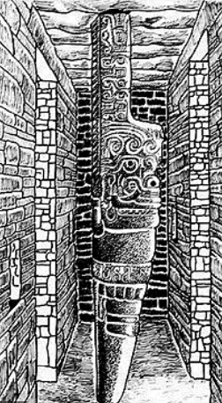 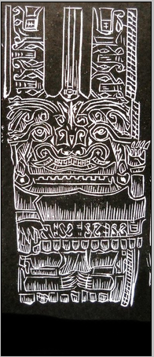 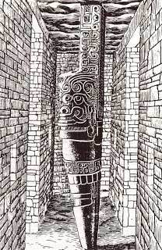

Figs. 2 a-c. The Lanzón (or Lance) in the subterranean Gallery at the center of the Chavín de Huántar temple showing the jaguar motif carved into the column suspended from the ceiling. A: <http://historiaperuana.pe/wp-content/uploads/lanzon-monolitico-chavin.jpg>, B: <http://pre07.deviantart.net/b2e2/th/pre/i/2011/192/d/2/__el_lanzon___by_xwalyx-d3n11v3.jpg>, C: <http://historiaperuana.pe/wp-content/uploads/lanzon-monolitico-chavin.jpg>.

**The jaguar monolith was far more powerful than a Conquistadore’s mere lance: it was the final psychological station for those who were undergoing the spiritual transformation into a jaguar men.** Devotees would be led into the maze of pitch-black tunnels, eventually coming face to face with the sculpture's snarling mouth and upturned eyes. The worshipers' disorientation, in addition to the hallucinogenic effects of cimora they were given before entering, only heightened the visual and psychological impact of the sculpture. The central jaguar bas-relief of the suspended granite pillar was a cosmological [*axis mundi*](https://en.wikipedia.org/wiki/Axis_mundi) linking the heavens, earth and underworld, positioned centrally within the temple at the most sacred location. The final act was to lie supine beneath the towering, suspended stone, dispensing with any ego and accepting the jaguar’s power and might to enter one’s being. Its similarity to the Christian Eucharist is provocative.

**LC Classification:** F3429.1.C48

**Date or Time Horizon:** ca 250 BCE

**Geographical Area**: Chavin de Huantar,

**GPS**: 9° 35′ 34″ S, 77° 10′ 42″ W

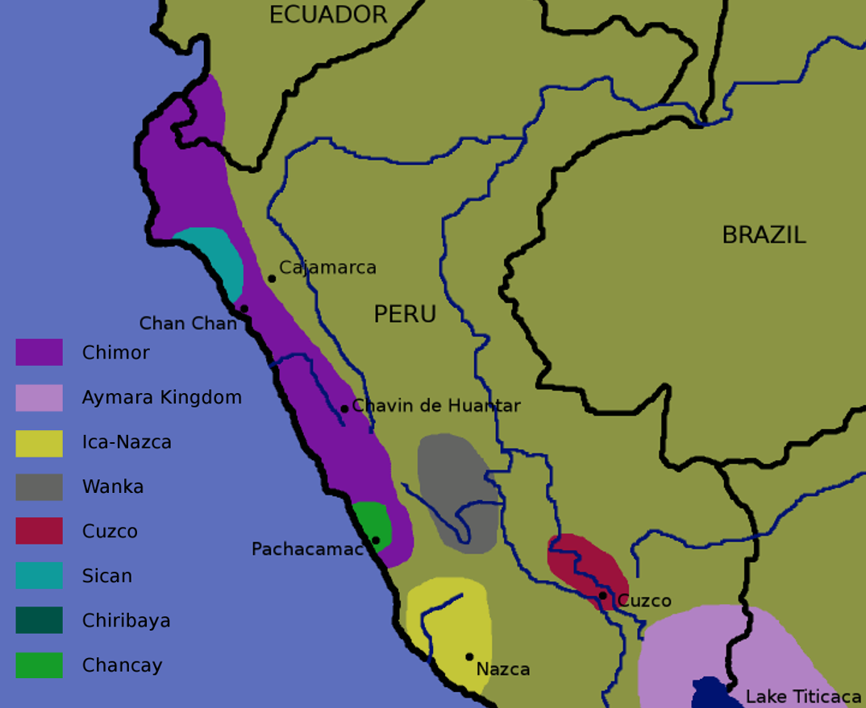

**Fig. 3. Map:** Chavín and related cultures after <https://upload.wikimedia.org/wikipedia/commons/6/6a/Late-intermediate-peru.png>

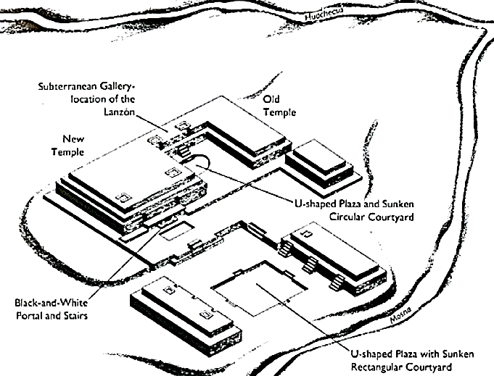

Fig. 4. Chavin de Huantar temple complex, after <https://hiddenincatours.com/wp-content/uploads/2014/07/chavintemple.jpg>; right after <http://www.crystalinks.com/chavin_old%20temple.jpg>

**Cultural Affiliation:** Chavín

**Medium:** granite

**Dimensions: L 6 in**  
**Weight:**

**Provenance: Vemeros Guzman, Piscobamba NZ23 hote 8 urb. los Noranjor, los Olivos, Lima 39 Peru**

**Condition:** original

**Discussion:**

The post-contact name “San Pedro” (St. Peter) Cactus, refers to the name given to it by Catholics to claim it as their own psychotropic drug “just as St Peter holds the keys to heaven, the effects of the cactus allowed users ‘to reach heaven while still on earth’” (Anderson 2001: 45-49). By naming their elixir in honor of a Catholic saint inquiries into *cimora* by the dreaded Inquisition was effectively averted.

*Cimora* is made from fresh chopped cactus flesh (the other flesh being anecdotally the most potent) that has been thoroughly dried in the sun (3 in thick and 10 in long for each dose). Then this is pulverized remembering that the finer the powder, the more effective the absorption of the mescaline. Then this powder is boiled for 5-7 hours with lime or lemon juice which assists in leeching the mescaline. Then the decoction is poured off and boiled again for 5-7 hours until only about half of the original volume remains.

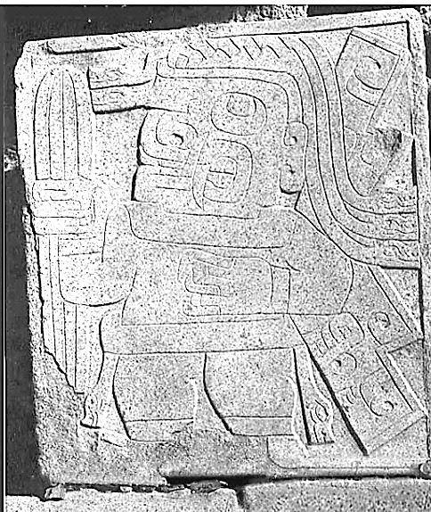 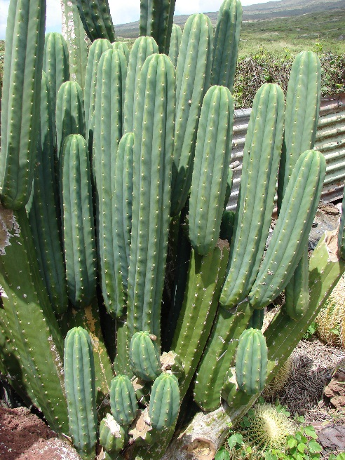

Fig. 5. A masked priest of the jaguar cult holding the sacred cimora cactus in a shallow bas-relief in the Chavín de Huántar temple. After <https://upload.wikimedia.org/wikipedia/commons/2/23/Chavin-cactus-stone.jpg>.

Fig. 6. *Cimora (Echinopsis pachanoi)* in Hawai’i, showing its columnar structure. After <https://upload.wikimedia.org/wikipedia/commons/6/62/Starr_070320-5799_Echinopsis_pachanoi.jpg>.

Chavín de Huantar was constructed in a sequence of perhaps fifteen phases and five stages. Beginning with high-volume structures containing gallery patios and elaborate galleries and ending with monumental low-volume structures containing standardized galleries: the trend suggests a shift from small internal patios based on discrete family units to large, decorated external spaces for communal gatherings. In the course of this progressive accommodation to an increasing population, the Lanzón monolith within the temple maintained its central importance (Kembel 2001).

In the initial Urabarriu period (900-500 BCE) the Chavin lived in dispersed settlements and depended on hunting and gathering as well as some primitive maize and potato agriculture. During this mostly egalitarian period a jaguar cult was developed.

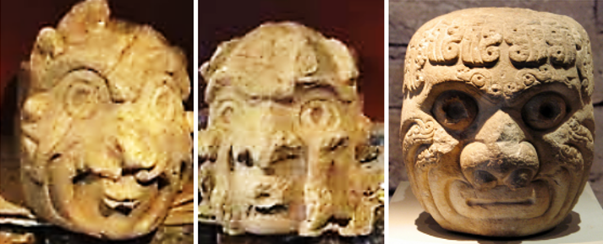 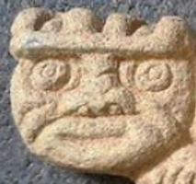

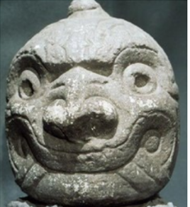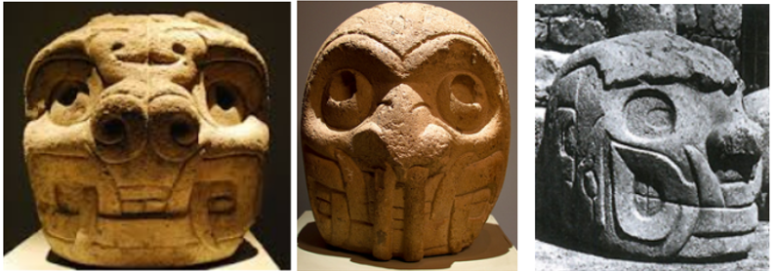

Figs. 4a-h. Representations of the jaguar from the Chavan de Huantar temple. The progression shown is from a transformational stage where the anthropomorph (the celebrant) is still observable as a human within a jaguar mask (Figs. 4a-d). Figs. 4e-g shows an anthropomorph with a jaguar mask and stylized fangs. Finally, Fig. 4h shows an anthropomorph face with a jaguar mask and highly stylized fangs and a stylized jaw. Note that in all stages of the progression the anthropomorph into a jaguar spirit the pupils are depicted as being dilated suggesting the subject has ingested hallucinatory drugs in a *cimora* brew.

Precipitously, in one century (500-400 BCE), these dispersed settlements were abandoned and the people coalesced around the main ceremonial center Chavín de Huántar, which was situated between the Mosna and Huachecsa Rivers. Hunting gradually diminished as a sedentary lifestyle ensued with the domestication of llamas and the development of maize agriculture. Trade expanded with outlying settlements. The jaguar cult became less of an egalitarian lifestyle and more of a cult of élites.

The final stage of the Chavín culture, the Jarabarriu Period (400-250 BCE), ensued precipitously. An ameliorated climate was accompanied by a dramatic increase in the production of crops and population. During this period the jaguar cult became mainly a cult of élites who celebrated their jaguar qualities. The cult of the jaguar had become a means of acquiring power. Now, those who were accepted into the cult, which had once required skill, strength, serenity and determination in performing the rites of defending Chavin territory, could do so without having to actually assimilate its quintessence. The cactus was their cure-all.

This plaque of the jaguar reflects this last stage of the Chavin culture. During this period the quintessence of the jaguar cult had departed. The extensive remodeling of the Chavin de Huantar temple now became the new emblem of an effete spiritual effort (Kembel and Rick 2005). The crowning crenellations, such as on this plaque, became symbols of an isolated culture. In reality, the basic defensive architectural structures were missing. Perhaps, the symbol of the threat of retaliation against foes enclosed in a jaguar plaque was believed to be enough to quell anxieties. However, this trust of an élite cult did not reflect the political reality, for warfare was a crowning factor in the last stage of Chavín culture, it was the instrument that hastened its end.

**References:**

Anderson, Edward F. 2001. The Cactus Family. Pentland, Oregon: Timber Press.

Burger, Richard L. 2008. "Chavin de Huantar and its Sphere of Influence", In H. Silverman and W. Isbell (eds.), *Handbook of South American Archeology*. New York: Springer, pp. 681–706.

Burger, Richard L., and Nikolaas J. Van Der Merwe (1990). "Maize and the Origin of Highland Chavín Civilization: An Isotopic Perspective," *American Anthropologist* 92(1):85–95.

Bussman, Rainer W.  and Douglas Sharon. 2006. “Traditional medicinal plant use in Northern Peru: tracking two thousand years of healing culture,” *Journal of Ethnobiology and Ethnomedicine*, **2**(47):1-18

Cruz Sánchez G. 1948. “Informe sobre las aplicaciones populares de la cimora en el norte del Perú,” *Revista de Farmacologia y Medicina Experimental Lim*a, 1: 253-258.

Dobkin de Rios M. 1969. “Folk curing with a psychedelic cactus in North Coast Peru,” *International Journal of Social Psychiatry*, 15: 23-32.

Kembel, Silvia Rodriquez. 2001. “Architectural sequence and chronology of Huantar de Chavín, Peru.” Ph.D. diss. Stanford University.

Kembel, Silvia Rodriquez and John W. Rick. 2005. “Building Authority at Chavin de Huantar: Models of Social Organization and Development in the Initial Period and Early Horizon.” In Helaine Silverman(ed.), *Andean Archaeology*, Malden, Massachusetts: Blackwell Publishers.

Pulgar Vidal, Javier. 1979. *Geografía del Perú; Las Ocho Regiones Naturales del Perú.* Edit. Universo S.A., Lima.

Rätsch, Christian. 2002. Enzyklopädie der psychoaktiven Pflanzen. Botanik, Ethnopharmakologie und Anwendungen. Aarau: AT-Verlag: p. 15.